Monday 8th July 2024

**RE: School Transport Service - Paid Travel**

Dear Parent/Carer

Pleckgate are pleased to continue working with Moving People to provide a bus service for our school children. This transport service means that we can offer a limited number of places on the bus to children who feel that they would benefit from using a bus to travel to and from school. For these children there will be a charge. The cost of the transport will be set at £2.75 per day return. We are offering this service either on an instalment basis or to be paid in advance. Bookings are now being taken for the period of Autumn half term 1 – Tuesday 3rd September 2024 to Friday 18th October 2024

Please note that the service will start on Tuesday 3rd September from the end of the school day at 3pm (this day will be free). The paid service will commence on Wednesday 4th September.

In order to reserve your place(s) please log onto your ParentPay account via the school website, select the trip titled ‘School Bus Service 1 24.25’, pay the full amount or first instalment and agree to the terms and conditions by Friday 30th August 2024. If you agree to pay by instalments, then you must keep up with the payment plan or your child will lose their place on the bus. Once payment is made we will contact you to confirm how your child(ren) can start to use the service. If you have any further enquiries please contact the school on **info@pleckgate.com**

If you have a child(ren) starting in Year 7 this September and are interested in using this service please fill out the form by following this link:

<https://forms.gle/s9m7T58SG15AZJNKA>

We will then write out to you with further details of how to access the service as you don’t yet have access to ParentPay.

The bus timetable is as follows (please see attached map):

**Morning**

07:40 Higher Audley Street, Audley

07:48 Whitebirk Road, Intack

07:54 Whalley Old Road, Little Harwood

08:00 Randal Street

08:10 Pleckgate High School

**Afternoon**

15:00 Pleckgate High School

15:10 Whalley Old Road, Little Harwood

15:15 Randal Street

15:27 Chester Street

15:35 Whitebirk Road, Intack

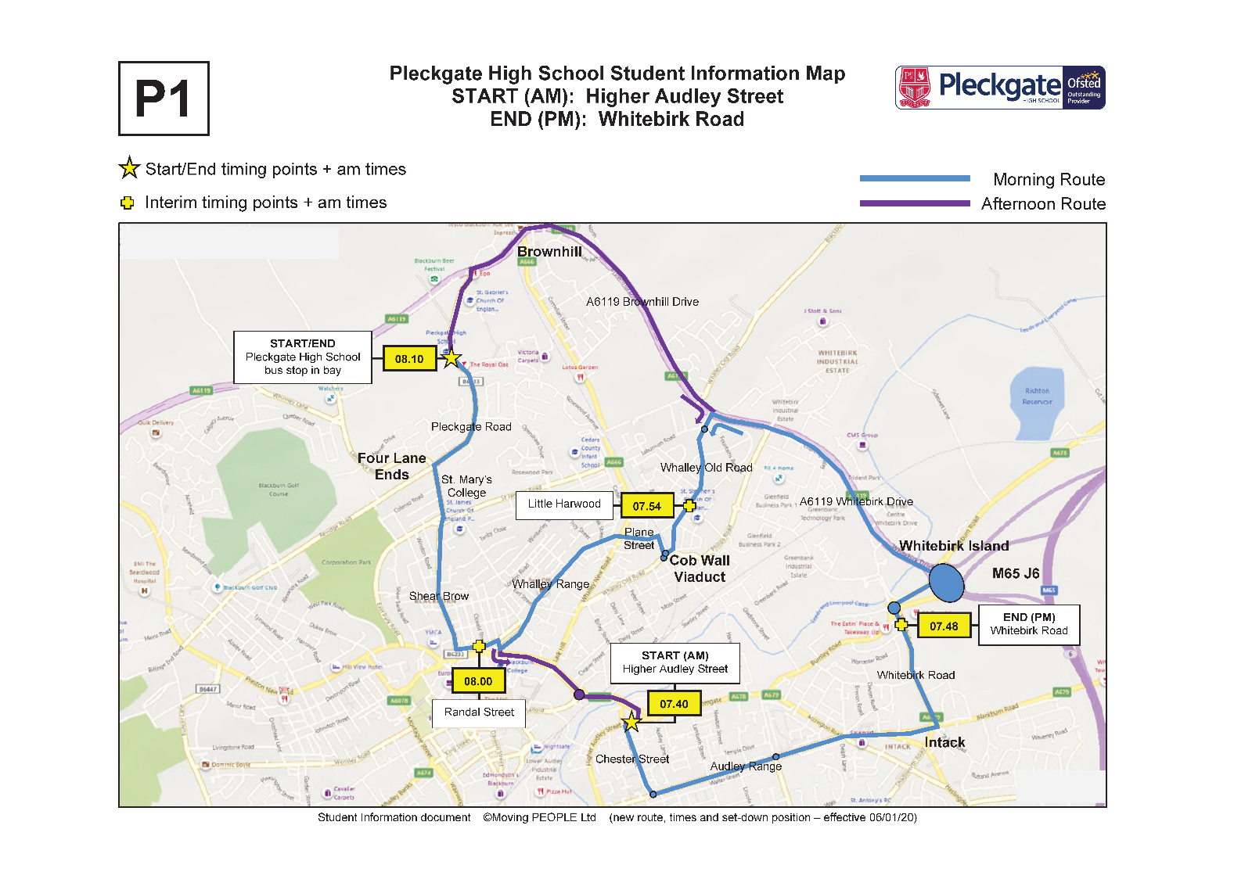

We understand that you and your child may have some concerns regarding transport to and from school. As a school we want you and your child to feel as safe as possible. In order to support this we are working very closely with Moving People and have put the following protocols in place:

* Seatbelts are provided and all children must be seated and wearing a seatbelt before the bus departs from its stop.
* A code of conduct is in place for parents to sign up to on commencement of the service.
* A seating plan will be in place for children to adhere to so that they are sat in year groups
* There will be a member of staff to greet the children when they arrive at school and at home time when they board the bus to ensure the seating plan is followed.

Yours sincerely



David Clark

School Business Manager